## **Introduction**

### Purpose of this document

The main purpose of this document is to specify requirements and constrains of 3 recommended systems: content management system, human resource management system and customer relationship management system.

Furthermore, general description of Cybercation café’s services and preliminary schedule and budget are also provided so that reader can have a better overview of the business and implementation plan.

This document is primarily intended to be proposed to a customer for its approval and a reference for developing the first version of the system for the development team.

### Scope of this document

This document covers functional requirements, interface requirements and hardware requirements for 3 recommended systems: content management system, human resource system and customer relationship management system.

All requirements will be described in detail, any constrain within a requirement will be clearly stated. User interface prototypes are provided so that our customer can have a better imagination of the way systems are used. Any data conversion needs will also be mentioned.

General description includes problem statement and objective of Cybercation café is also provided why the above systems are recommended. Furthermore, general constrains and characteristics of users of those systems are classified and listed to help improve user experiences to recommended systems.

Preliminary schedule and budget for implementation of recommended systems are anticipate and stated as the last section of the document for better preparation plan. Preliminary schedule and budget are predicted may change depend on additional and changed requirement during implementation.

All information in this document is necessary for implementation team to implement the desired systems and must be agreed by all stakeholders.

Elicitation team for this project is group 3 which includes:

* Phan Thế Hùng
* Đặng Thị Thảo My
* Bùi Nguyễn Thiện Khánh
* Nguyễn Anh Quân

Customers of this system are the cybercation café’s owners which includes:

* A barista
* An administrator
* An online game enthusiast
* A sale person
* A computer engineer

This CMS will be developed and tested on group 3 computer. After the CMS has been approved by the Cybercation café owners, it will be deployed on an apache web server.

### **Overview**

Through this requirement specification process, all functional, interface and hardware requirements along with constrains will be described in detail. All necessary information for implementation of recommended system is provided through this document. The result will be sent to stakeholders for approval and developer team for implementation.

This document may be updated over time.

### Business Context

The sponsor for this project is the Cybercation café. They are a group of five people who want to create a new business café model. Beside from original café model, the Cybercaion café also provides other services such as:

* E-learning packages for industry certification
* Testing for industry certification
* Training/conference room for hire
* Photocopy/scanning services
* Graphic design and print
* Web server and hosting

The Cybercation café is a newly establish business. In the first 12 months, they want to focus on expanding the business internationally. They are going to open the first shop in Ho Chi Minh City and the second one in Hanoi. They also want to implement a customer loyalty program and will invest in technology to archive these following goals:

1. To provide Internet services, E-Learning, testing, graphic... throughout the Asian region that are of top quality, reliability
2. To provide technological feature, to achieve strategic goal (1) (*).
3. To encourage and prepare our human resources team to enhance their knowledge and skills within each featured context.
4. To increase growth and development through business expansion
5. To make use of information technology to achieve our goals, objectives, and CSFs and to add value to the business Value Chain and Supply Chain
6. To grow the business by attracting regular business customers who can easily access our services in all our locations through a customer loyalty system.
7. To maintain profitability and build a consolidated fund to use for expansion costs

## **General Description**

### User Problem Statement

Our customers are facing 3 problems corresponding to 3 solutions which we suggested

1. The Cybercation café needs a CRM system which allows them to receive request, feedback from their customers. In addition, the system helps the Cybercation café to categorize and keep track of those requests, feedbacks as they are being processed. The system also includes online communicating function so that the business’ customer can receive real time guidance.
2. The Cybercation café needs a HRM system to manage and evaluate their human resource. As a result, they can prepare their training, recruiting, retiring plan better.
3. They need a CMS system to manage contents and operations on their official website in a quick and effective way. Furthermore, the system allows their customer to access their services anywhere, anytime.

### User Objectives

* Set up a communicating channel between the Cybercation café and customer, provide real time support and guidance
* Establish and maintain good relationship to customer
* Make up an effective human resource strategy
* Manage employees, discover talented employee
* Promote Cybercation café brand and services
* Establishment of e-business (through the use of website) to make web-based bookings for Cybercation services, and search for locations where our Cybercation business are situated

### User Characteristics

Users of suggested system are divided into 2 groups

1. Employees of Cybercation café:
   * Skillful users (trained by system provider)
   * Have good knowledge about their profession
   * Evaluated and trained due to Cybercation café policies
2. Customer of Cybercation café:
   * General users
   * Mostly young people (under 35 years old)
   * Willing to study
   * Familiar with the internet, website, social network, e-application although some users will need support
   * Prefer quick, convenient, simple actions to achieve their goals
   * Desire to study with minimum amount of money
   * Cosmopolitan

### Similar System Information

There is no installed solution in Cybercation café. All 3 suggested solution are stand-alone system.

### General Constraints

Lists general constraints placed upon the design team, including speed requirements, industry protocols, hardware platforms, and so forth

* The website must be adaptable to common protocols which provide internet connection and web service such as HTTP, HTTPS, TCP/IP, RESTFUL, etc…
* Response time of each system must less than 3 second
* Each system must be provided with recovery plan and warranty
* Hardware platform must be produced in 2010 or later

## **Functional Requirements by Application**

This section lists the functional requirements within each of the recommended applications in ranked order. Functional requirements describe the possible effects of a particular software system (such as an accounting system), in other words, *what* the system must accomplish. Other kinds of requirements (such as interface requirements, performance requirements, or reliability requirements) describe *how* the system accomplishes its functional requirements.

Functional requirements will be described in terms of ‘must’, ‘should’, ‘could’, or ‘ideally could’.

Each functional requirement should be specified in a format similar to the following…

### Functional Requirements of: Content Management System

#### **Scope requirement for content management system (CMS)**

Content management system is a web-based system which manages all operations on web server and contents of the official website of the company. All interactions between users and the CMS are processed through web interface.

This section describes functions which are performed by authorized people to manage content of the Cybercation café. The manager has all the authority to view, create, update and delete any content of the website. In addition, valid actions which Cybercation café’s customers can take in order to use Cybercation café’s services are also described in detail.

All accesses and requests are verified and controlled by the CMS. At the end of month, the CMS will create a report about registered courses and services.

The CMS will also provide APIs which allow human resource department to upload announcements which relates to human resource activities such as recruitment, trainings, etc… to the website.

#### **Functional requirements within content management system**

The application must have 2 modules:

* Courses information maintaining and updating system
* Courses registering and participating system

##### **Courses information maintaining and updating module**

* + - * 1. Add a new course

Authorized people can add a new course which is provided by Cybercation café to the website through web interface

* + - * 1. View a course

Authorized people can view information of a course which is provided by Cybercation café on website through web interface

* + - * 1. Modify a course

Authorized people can modifies information of a course which is provided by Cybercation café on website through web interface

* + - * 1. Delete a course

Authorized people can delete a course which is provided by Cybercation café from website through web interface

* + - * 1. Add a new test

Authorized people can add a new test to website through web interface

* + - * 1. View test

Authorized people can view information of a test which is provided by Cybercation café to the website through web interface

* + - * 1. Modify a test

Authorized people can modifies information of a test which is provided by Cybercation café on website through web interface

* + - * 1. Delete a test

Authorized people can delete a test which is provided by Cybercation café from website through web interface

* + - * 1. Add a new user

Authorized people can add a new lower level user to user list through web interface

* + - * 1. View a user

Authorized people can view information of a lower level user to user list through web interface

* + - * 1. Modify a user

Authorized people can change information of a lower level user to user list through web interface

* + - * 1. Delete a user

Authorized people can delete a lower level user from user list through web interface

* + - * 1. Add a new announcement

Authorized people can add a new announcement to the website through web interface

* + - * 1. View an announcement

Authorized people can view information of an announcement through web interface

* + - * 1. Modify an announcement

Authorized people can modifies information of an announcement on the website through web interface

* + - * 1. Delete an announcement

Authorized people can delete an announcement from website from the website through web interface

* + - * 1. Add a new category

Authorized people can add a new category to category list through web interface

* + - * 1. View a category

Authorized people can view information of a category in category list through web interface

* + - * 1. Modify a category

Authorized people can modifies information of a category in category list through web interface

* + - * 1. Delete a category

Authorized people can delete a category in category list through web interface

##### **Courses registering and participating module**

* + - * 1. Registering

New customer can register a member account through web interface

* + - * 1. Enrolling courses

Members can enroll courses through web interface

* + - * 1. Taking test

Members can take tests through web interface

* + - * 1. Modifying personal information

Members can modifies their personal information through web interface

* + - * 1. Changing password

Members can change their password through web interface

* + - * 1. Login

Members can login to their account on the website

* + - * 1. Logout

Members can logout of their account

* + - * 1. Verifying user

The CMS can verify logged-in member and assign appropriate authority.

* + - * 1. View personal information

Members can view their personal information through web interface

* + - * 1. Monthly report

The CMS will record members’ activities such as courses and tests they take, theirs searching keywords. At the end of each month, the CMS will generate reports on those activities.

### Functional Requirements of Human Resource Management System (HRMS)

#### **Scope requirement** FOR HUMAN **resource management system (**HRMS**)**

HRMS is a web-based system which support the HR department to manage employees. All interactions between users and the HRMS are processed through web interface.

The manager has all the authority to view, create, update and delete any recruitment record. Employees’ accounts will be created by the manager. At the end of month, the HRMS will generate reports on the performance of employees and the insight of various aspects of the HR management of the company.

The HRMS will also use an APIs from CMS which allow human resource department to upload announcements which relates to human resource activities such as recruitment, trainings, etc… to the website.

#### **Functional requirements within HRMS**

The application must have 2 modules:

* Human resource management system
* Employee’s working hours, activities, skills, experience and quality evaluating and ranking system. We can call it Performance tracking system for short.

##### **Human resource management module**

* + - * 1. Login

Users of the HRMS can login to their account on the website.

* + - * 1. Logout

Users can logout of their account.

* + - * 1. Verifying user

The HRMS can verify logged-in member and assign appropriate authority.

* + - * 1. View personal information

Users can view their personal information through web interface.

* + - * 1. Add a new employee’s record

Authorized manger can add a new employee’s record through web interface of HRMS.

* + - * 1. Search for an employee’ record

Authorized manger can search for an employee record through HRMS interface.

* + - * 1. View an employee’ information

Authorized manger can view information of an employee through HRMS interface.

* + - * 1. Modify an employee’s details

Authorized people can modifies information of an employee through HRMS web interface

* + - * 1. Delete an employee’s record

Authorized manager can delete a record which is provided by through HRMS web interface.

* + - * 1. Add a new HR announcement

Authorized people can add a new HR announcement to the website through web interface

* + - * 1. View a HR announcement

Authorized people can view information of an announcement through web interface

* + - * 1. Modify a HR announcement

Authorized people can modifies information of an announcement on the website through web interface

* + - * 1. Delete a HR announcement

Authorized people can delete an announcement from website from the website through web interface

##### **Performance tracking module**

* + - * 1. Create a timesheet

Authorized manger can add a new timesheet to track employee attendance through web interface of HRMS.

* + - * 1. Edit a timesheet

Authorized manger can edit a created timesheet through web interface of HRMS

* + - * 1. Delete a timesheet

Authorized manger can delete a created timesheet through web interface of HRMS

* + - * 1. Create a performance review

Authorized manger can create a performance reviews using key performance indicators (KPIs) depending on job position through web interface of HRMS

* + - * 1. Generate monthly reports

The HRMS will track employee activities encompassing: tasks, attendance, and performance. At the end of each month, the HRMS will generate reports on those activities.

### Functional Requirements of: Customer Relationship Management System (CRM).

#### **Scope requirement for customer relationship management system (CRM).**

Customer Relationship Management System (CRM) is designed to collect information, requests and maintain good relationship on customers across various channels, especially through the Cybercation’s café website. Well-structured CRM will satisfies customers and create customers’ loyalty.

Customer will have ability to submit a ticket (request) for their problem or question that related to services which are provided by Cyberations’ café. This can be done by user account or as an anonymous. Tickets will be analysed and separated to appropriate people within 24 hours with different level of priorities. CRM will also provide a FAQs page, a list of questions and answers that are commonly asked when using our services. Customer who raise requests will able to track their ticket as well, basically tickets will have 3 status: sent, pending for answer and solved. Answer will be sent to user’s personal account or can be listed into FAQs page if it is commonly questioned. Live chat will available during the office hours which give customer a fast and direct support from our Helpdesk team.

From the Helpdesk side, when logging to helpdesk account, they will have permission to check new tickets, change tickets’ status, separate ticket to appropriate categories, and answer or guide customers through email or live chat system.

CRM also automatically generate report with metrics, KPIs and statistics weekly.

#### **Functional requirements within customer relationship management system (CRM):**

The Application will have 2 modules:

* Requests categorizing, tracking, processing system.
* Online consulting and guidance system.

##### **Request categorizing, tracking, processing system**

* + - * 1. Raise new ticket (user side).

Users or anonymous can submit tickets to helpdesk team.

* + - * 1. View tickets (user side).

Only users can view, modify or add new related tickets, anonymous will receive answers through their email account.

* + - * 1. Track tickets’ status (user side).

Users can track their tickets’ status when log to view ticket page.

* + - * 1. Overview dashboard (Helpdesk side).

Helpdesk can open overview page to easily control tickets.

* + - * 1. View tickets (Helpdesk side)

Helpdesk can view detail information of the ticket

* + - * 1. Separate tickets (Helpdesk side).

Helpdesk can separate tickets to appropriate department.

* + - * 1. Change tickets status (Helpdesk side)

Helpdesk can change the tickets’ status to: pending for answer or solved.

* + - * 1. Delete a tickets (Helpdesk side).

Helpdesk can delete a ticket if it contain sensitive information or not related to Cybercations’ café services.

* + - * 1. Rate ticket priority (Helpdesk side)

Depends on problems’ seriousness helpdesk will rate the priority of the ticket and send to appropriate people.

* + - * 1. Weekly report.

CRM will automatically generate a report that content statistics from both customer and helpdesk side to determine the efficient of the system.

* + - * 1. Appointed person can also update tickets’ status

Tickets status can be updated by accounts that are appointed by administrator.

* + - 1. **Online consulting and guidance system**
         1. Live chat service

Helpdesk can answer customers question throughout live chat windows during office hours

* + - * 1. FAQs page

Helpdesk can post, edit or delete a question.

## **Interface Requirements**

### Interface Requirements of content management system (CMS).

#### **Courses information maintaining and updating module**

##### **User Interfaces**

Interaction between users and course information maintaining and updateing module will be processed through web interface

* + - * 1. **GUI**

The course information maintaining nad updateing module will be menu-driven system which includes a left side menu. The menu includes categories and sub categories as the following picture:

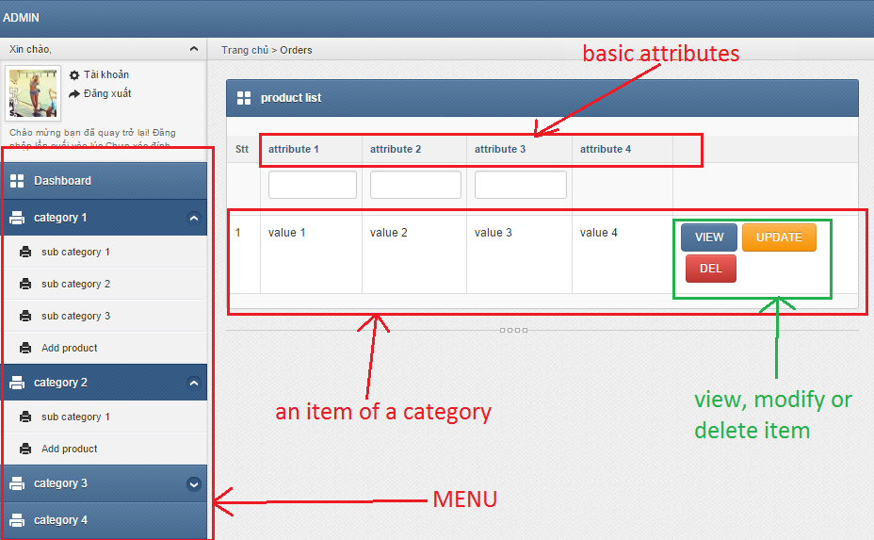

**View function interface (attribute change due to category )**

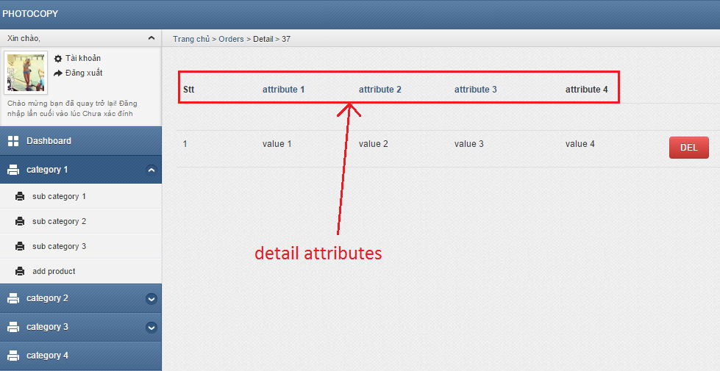

**Modify function interface (attribute change due to category)**

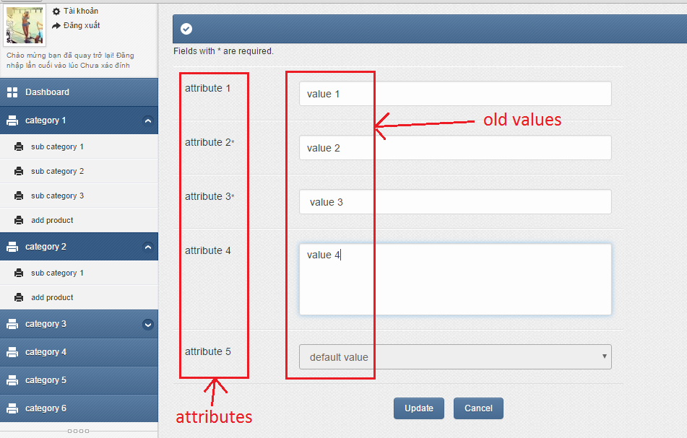

**Create function interface (attribute change due to category)**

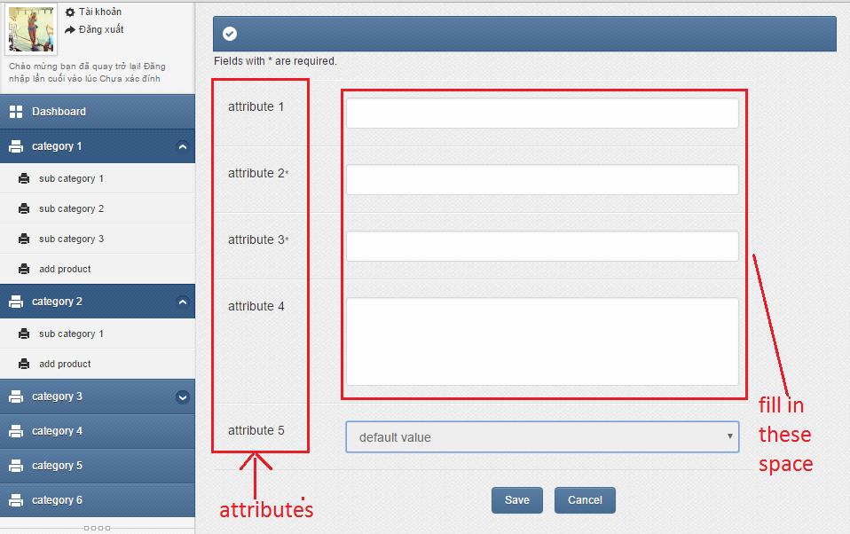

* + - * 1. **Ease of use**

- Minimum (no redundant), logical steps needed to process a task

- Consistent, simple layout (not too many components)

- Clear, readable, text font

- Understandable, informative, positive error message

- Guidance documentation

- Cross-browser support

- Informative icons, graphics.

* + - * 1. **Task match**

The course information maintaining and updating module will be 100% match to all functional requirements

* + - * 1. **User support**
* System training
* Service desk support: 2
  + 4/7 through email
  + working hour from Monday to Saturday through phone
* data backup and recovery
  + - * 1. **Perceived consequences**

This module let manager know what information will appear on the website in a visual way. As a result, the manager can give a faster, more reliable and more effective decision about the website’s content.

#### **Courses registering and participating module**

##### **User Interfaces**

Interaction between users and course courses registering and participating module will be processed through web interface

* + - * 1. **GUI**

The course courses registering and participating module will be menu-driven system. The menu includes categories and sub categories as the following picture

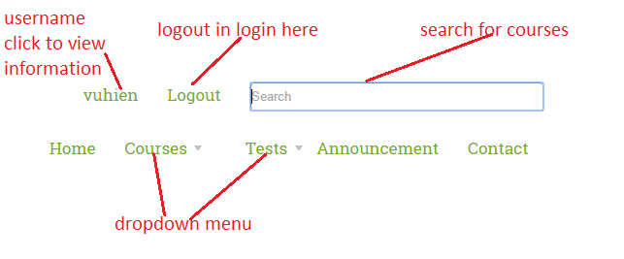

**Register interface**

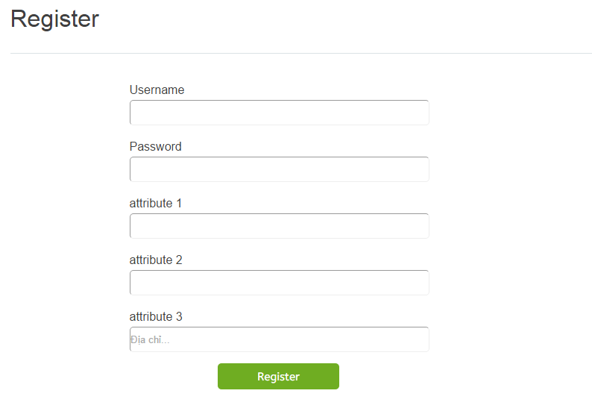

**Login interface**

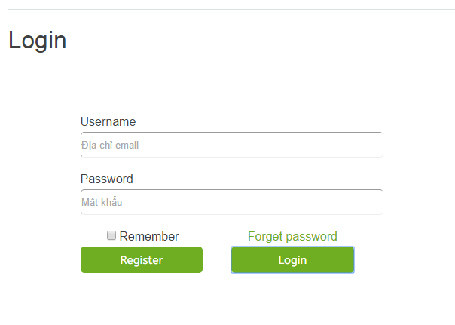

**Personal information interface**

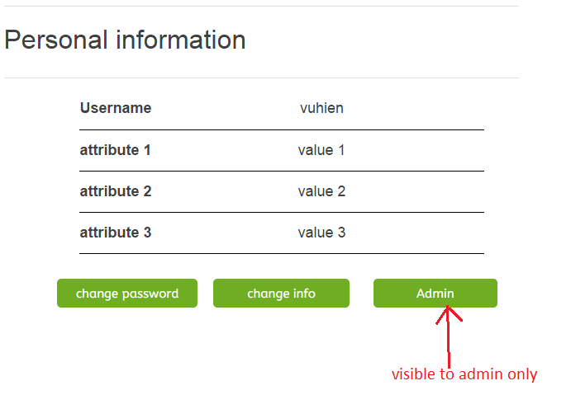

**Change personal information interface**

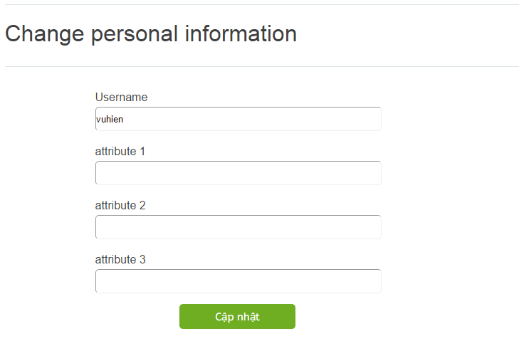

**Change password interface**

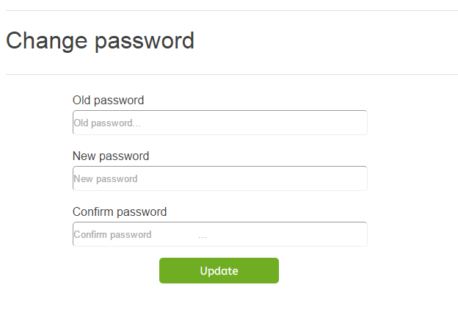

* + - * 1. **Ease of use**

- Minimum (no redundant), logical steps needed to process a task

- Consistent, simple layout (not too many components)

- Clear, readable, text font

- Understandable, informative, positive error message

- Guidance documentation

- Cross-browser support

- Informative icons, graphics.

* + - * 1. **TASK MATCH**

The course information maintaining and updating module will be 100% match to all functional requirements

* + - * 1. **USER SUPPORT**
* System training
* Service desk support:
* 24/7 through email
* working hour from Monday to Saturday through phone
* data backup and recovery
  + - * 1. **PERCEIVED CONSEQUENCES**

The website will help to promote the business over the internet. Customer can access to the services at anywhere, anytime and the user interface is very easy to use, therefore, it helps to attract more customers and make them feel comfortable. The course courses registering and participating module will automate and accelerate registering and courses participating processes and help users to find their desired courses.

### User interfaces of HRMS

All users will see the log-in page when they access HRMS. The log-in page requires users to enter a username and a corresponding password.

Figure Login form

OK

Username:

Password:

After the user is authenticated, they can see the main web page interface of HRMS. The log-out button is on top right corners below the user role type. The main interface has a menu bar showing various tab functions depending on the user role type. All the users will see Personal Info Management Tab (PIM). If the role is manager, the menu will contain Manage Employee Tab, Announcement Tab, and Reports Tab. When users click on a tab, quick launch icons of all functions of that tab will show up. Users can select any of them to perform their tasks.

The function icons in each tab is described as follow:

PIM: Update information, Change password.

Manage Employee: Create timesheet, tracking work time, Add Employee Record, Search a record, Modify a record, Delete a record.

Announcement: Post, Edit, Delete.

Reports: performance report, employee report, HR plan

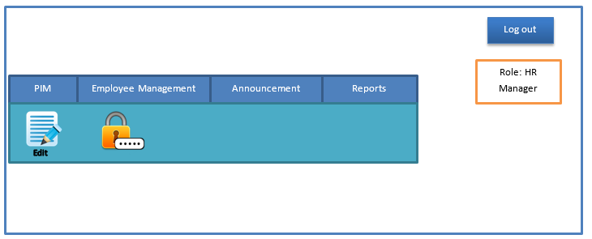

Figure MAIN INTERFACE OF hrms

**4.2.1. Ease of use**

- Minimum (no redundant), logical steps needed to process a task

- Consistent, simple layout (not too many components)

- Clear, readable, text font

- Understandable, informative, positive error message

- Guidance documentation

- Cross-Brower support

- Informative icons, graphics.

**4.2.2. TASK MATCH**

All the modules of HRMS will be 100% match to all functional requirements.

* + 1. **USER SUPPORT**
* System training
* Service desk support:
* 24/7 through email
* working hour from Monday to Saturday through phone
* data backup and recovery
  + 1. **PERCEIVED CONSEQUENCES**

The HRMS website will facilitate the activities of HR department. HR staff or employees can access to the HRMS at anyplace having internet access. This system will help HR department has an effective way to manage employees of the company and recruit new positions. It also give detailed reports about the performance of employees.

* 1. **Interface Requirements of Customer Relationship Management System (CRM)**

#### **Requests categorizing, tracking, processing system**

* + - 1. **USER INTERFACES**

Interaction between users, helpdesk and requests categorizing, tracking, processing system, online consulting, guidance system will be done through web interface

* + - * 1. **GUI**

User login pop-up windows:

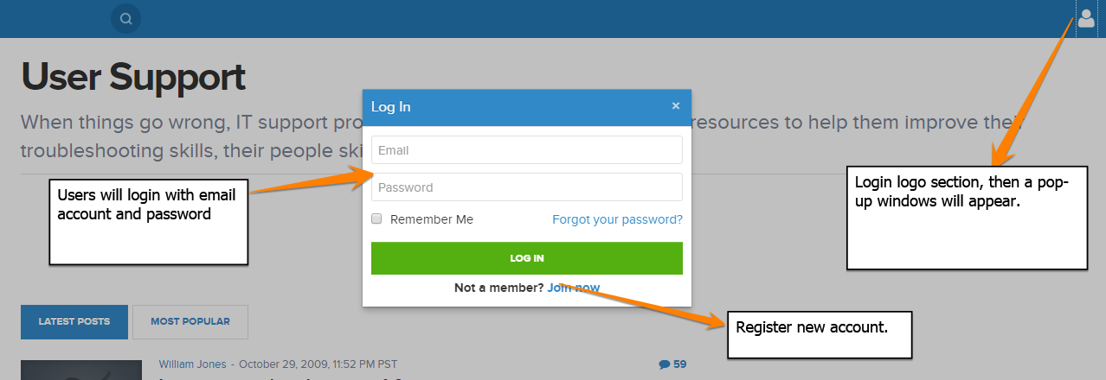

Register new account pop-up windows:

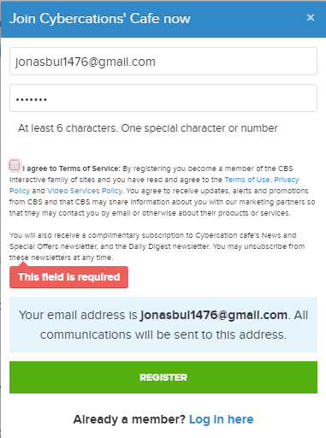

Users’ console on top-right screen of the website.

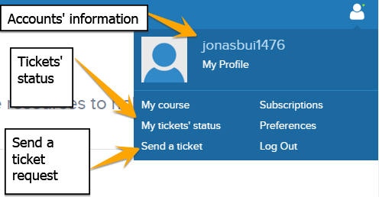

Send ticket as users’ account:

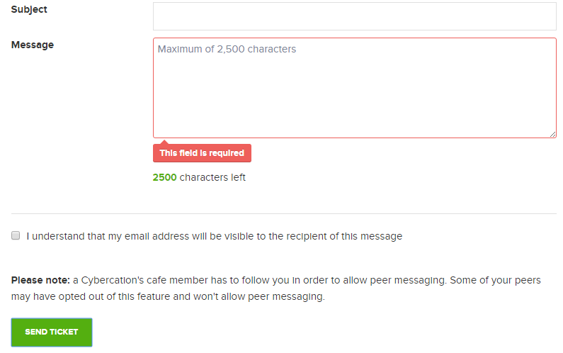

Dashboard from helpdesk’s side:

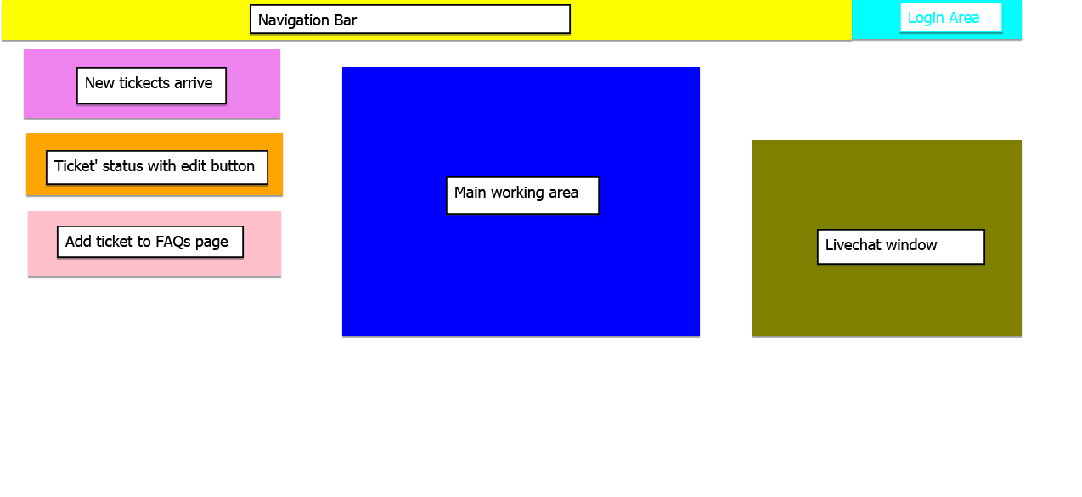

* + - * 1. **Ease of uses**
* Logical steps needed for wide-range of user can use the system easily
* Responsive design for different devices.
* Clear error messages and guidance.
* Live chat system need to fast response.
  + - * 1. **Task match**

All the modules of CRM will be 100% match to all functional requirements.

* + - * 1. **User support**
* System training
* Data backup and recovery weekly
  + - * 1. **Perceived consequences**

The CRM website will progress tickets and notify the helpdesk immediately. Passwords will be encrypted to prevent hacking into the system, personal information will be kept to protect customers’ interests.

* + 1. **Online Consulting and Guidance System.**
       1. **GUI**

From customer’ side as an anonymous, request page will be organized as the following image:

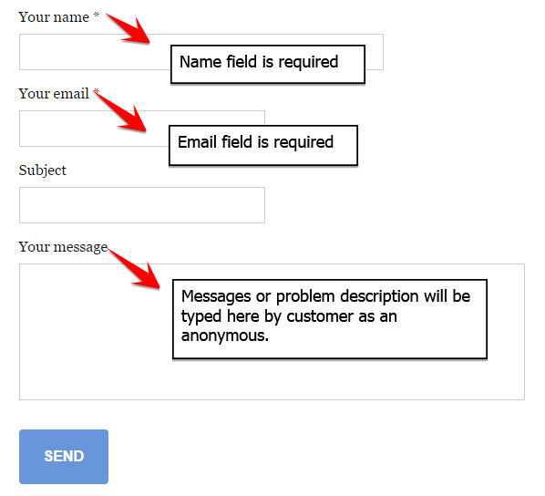

Send ticket as users’ account:



Live chat widows at bottom-right of the site.

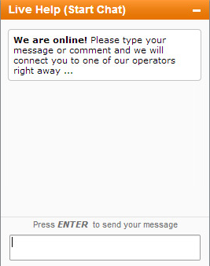

Dashboard from helpdesk’s side:



FAQs pages’ view

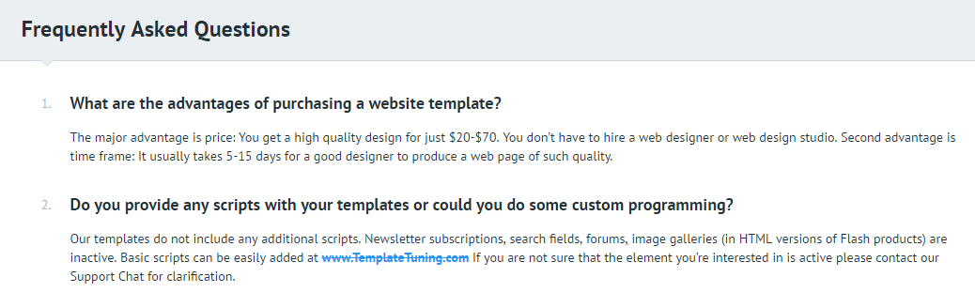

* + - 1. **Ease of use:**
* Clear and keep the simple step for customer to follow
* Fast response for live chat window.
* Customer can search for answer in FAQs easily
* Guidance provided.
* Can be performed in different devices, operation systems.
  + - 1. **Task Match**

All the modules of CRM will be 100% match to all functional requirements.

* + - 1. **User Support**
* System training
* Service desk support during office hour.
* Data backup and recovery weekly.
  + - 1. **Perceived Consequences**

Through website interface, customer can easily raise their request, question in many different ways. System will help to improve customers’ royalty and maintain good relationship between Cybercations’ café and customers. Weekly statistics report is provided weekly for determining systems’ efficiency.

## **platform requirement**

*Describes interfaces to and requirements for hardware devices*

### Hardware:

* Black white and colour printer
* 15 inches screen
* At least 5 CPUs, keyboards, mouses, screens produced from 2010 or later
* At least 1 routers
* At least 1 telephone

### Estimated capacities (CPU speed, memory size, online & offline storage).

* 4GB or higher ram CPU
* At least 150GB of memory storage
  1. **Operating System and Database Requirements**
* Microsoft SQL server
* Microsoft window 7 or higher

### Networking, Internet, Communications Requirements

* Lighting cable internet

### Data Backup, Recovery

* Backup recovery plan for of disaster
* Backup and recovery plan for data lose
* Backup electricity power
* RAID 3 or higher

### Security (Virus Protection, Firewall)

* Common antivirus software is required (Avast, Avira, etc…)
* Window firewall

## **Data Conversion**

The Cybercation café is a newly established business. Therefore, only basic information (such as offered courses, company location, etc… ) will need to be import manually to the system

1. **Preliminary Schedule**

* **Schedule for content management project**

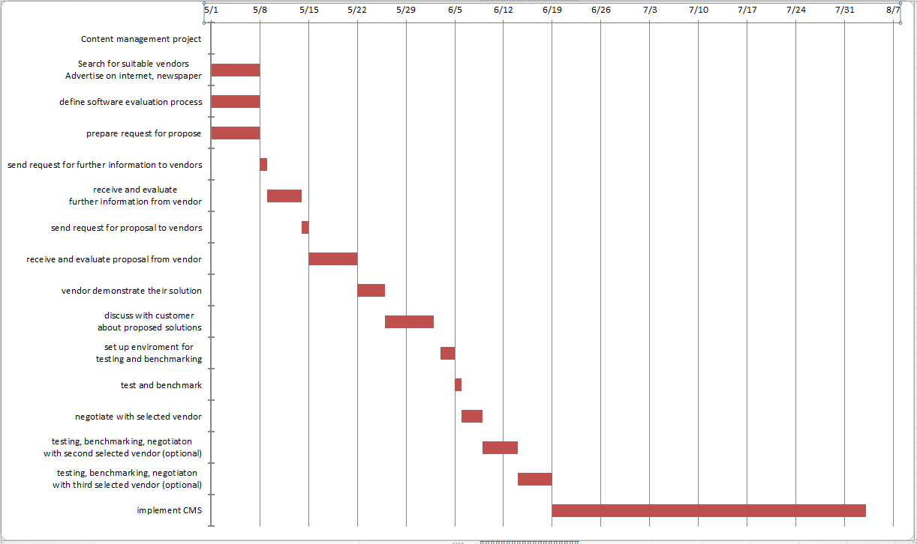

For more detail, please see sheet1, PreliminarySchedule.xlsx file.

## **Preliminary Budget**

* Content management system: 600$
* Customer relationship management system: xxx $
* Human resource management system: xxx $
* Host and domain: 150$ per year
* Support and maintenance (software): 150$ per year
* Network: 210$ per year
* Devices: 5PC + 5 keyboard + 5 mouse + 1 printer = 3500$
* Training: 100$ per year

**References**  
Provides complete citations to all documents and meetings referenced or used in the preparation of this document.

**Appendices**

Specifies other useful information for understanding the requirements. All SRS documents should include at least the following two appendices:

**A: Recommended application supporting information/ documents**

**B: Minutes of JAD meetings**